## EXPERIMENT 5

**AIM:** Aim: To find the length of string using assembly level language

**THEORY:** The Compare Statements of the ALP used are as follows:

JE --> It implies Jump if equals.

JMP--> It is a jump statement used to jump at a label

CMP--> It is a compare statement it is used to compare source with the destination.

1. Rep--> REP: The REP prefix, when set before a string instruction, for example - REP MOVSB, causes repetition of the instruction based on a counter placed at the CX register. REP executes the instruction, decreases CX by 1, and checks whether CX is zero. It repeats the instruction processing until CX is zero.
2. Offset--> MOVSB: The MOVS instruction takes four basic forms. MOVS moves bytes, words, or double words, MOVSB moves byte strings,MOVSW moves word strings,
3. MOVSP--> OFFSET: offset keyword refers to the offset from the segment in which it is defined.

**ALGORITHM**:

1. Initialize SI to input the Source String.
2. Initialize DI to store the final count
3. Load AX with ‘$’ to compare it with the string that whether the string has ended or not.
4. Perform looping operations along with increasing the count as well as SI
5. No sooner the ‘$’ is detected than the program terminates.

### 

PROGRAM AND EXECUTION SCREENSHOT:

Program: mov si,1000h

mov di,2000h

mov cx,00h

mov al,'$'

Back:cmp al,[si]

je Next

inc cl

inc si

jmp Back

Next:Mov [di],cl

hlt

mov ax,4ch

int 21h

Output: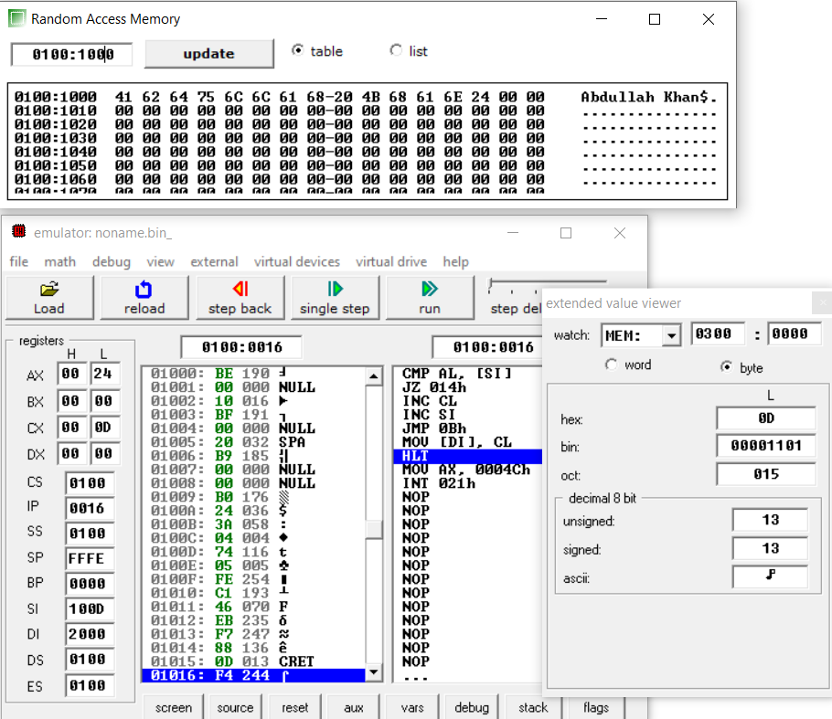

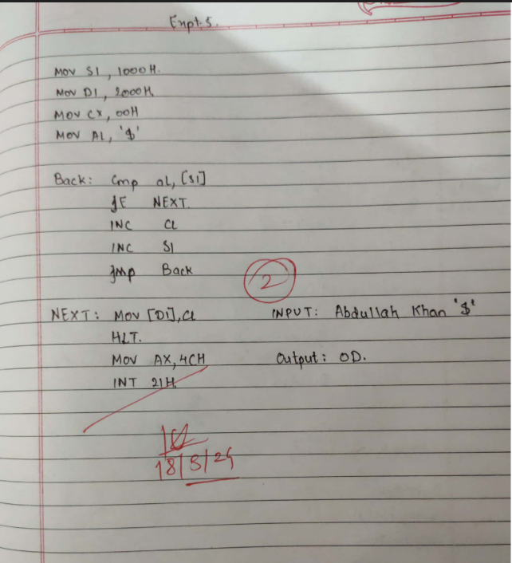

**CONCLUSION**: With the help of assembly level programming we have executed the program for Counting the length of string.

Name :Abdullah Khan

Roll No: 122A1002 --(02)

Batch :C1 Batch